VsCode Setup and styling recommendations
Contents
VsCode Setup and styling recommendations 1
Visual Code Setup: 2
Styling Guides 3
Guideline Exceptions: 4

Visual Code Setup:
Make tabs default to spaces: 2 | .net developers are more used to tab:4, but tabs in javascript jsx and html can quickly expand beyond readability. Let’s keep the tabbing consistent across the development team:  Vscode:  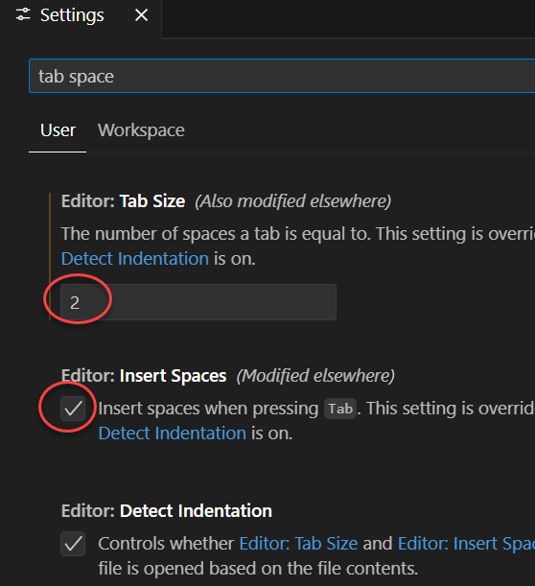  Watch and fix tab errors to spaces:2
Keep vs Code extensions to a minimum | It’s already extremely difficult to get extensions in the bank, but that’s a separate discussion.  I recommend the following minimum:  - GitLens  - Prettier  - (open to others, but should be reviewed by committee)  Note: AI assisted extension are NOT allowed in bank, though there are some discussions. AI is useful but needs careful review by developer… it’s way too “helpful” and can create perfectly reasonable looking, incorrect code.
Keep code formatted by using:  <Shift>+<Alt>+F | This ensures that the code formatting stays consistent between developers.  Use prettier-ignore and eslint-disable if needing to override auto-formatting  //prettier-ignore  import {  Home, //separate lines helps Merging  About  } from "./pages";  //code that formatting would mangle, such as too much formatting in the jsx  // eslint-disable-next-line

Styling Guides
Rather than create our guidelines from scratch, the following guidelines are recommended. Note the guideline exceptions listed afterwards.
Guideline | Reasoning
Airbnb javascript guide | good guideline that has withstood the test of time
Airbnb react guide
https://sass-guidelin.es/

We can discuss adding the esLint for these guidelines, but will need to make some modifications; imo air bnb is TOO opinionated by default.

(continued on next page…)

Guideline Exceptions:
Recommendation | Reasoning
Folder names should use kabab-case instead of camelCase or PascalCase | - Casing can lead to difficult to spot errors during import {} from ‘whAtever’  - Bitbucket is NOT case sensitive; leads to difficulties if a casing mistake is made. Fixing a casing error with multiple developers is a special kind of hell.  - We are deploying to NGINX or Apache, both of which are case sensitive. Although the react code is “compiled”, adopting kabab-case is good practice
Filenames should be kabab-case (preferred) or camelCase | - Casing leads to errors.  - If determined not to use kabab-case, use the javascript variable naming convention, which should be baked into muscle memory.  - Bitbucket is NOT case sensitive; dealing with a casing error with multiple developers is a special kind of hell.
Import React no longer needed | Since 2020, components no longer need import React
ALL Component names should be PascalCase. | The guide has an odd recommendation to make subcomponents lowercase. React requires components start with uppercase, so it makes sense to use PascalCase.

